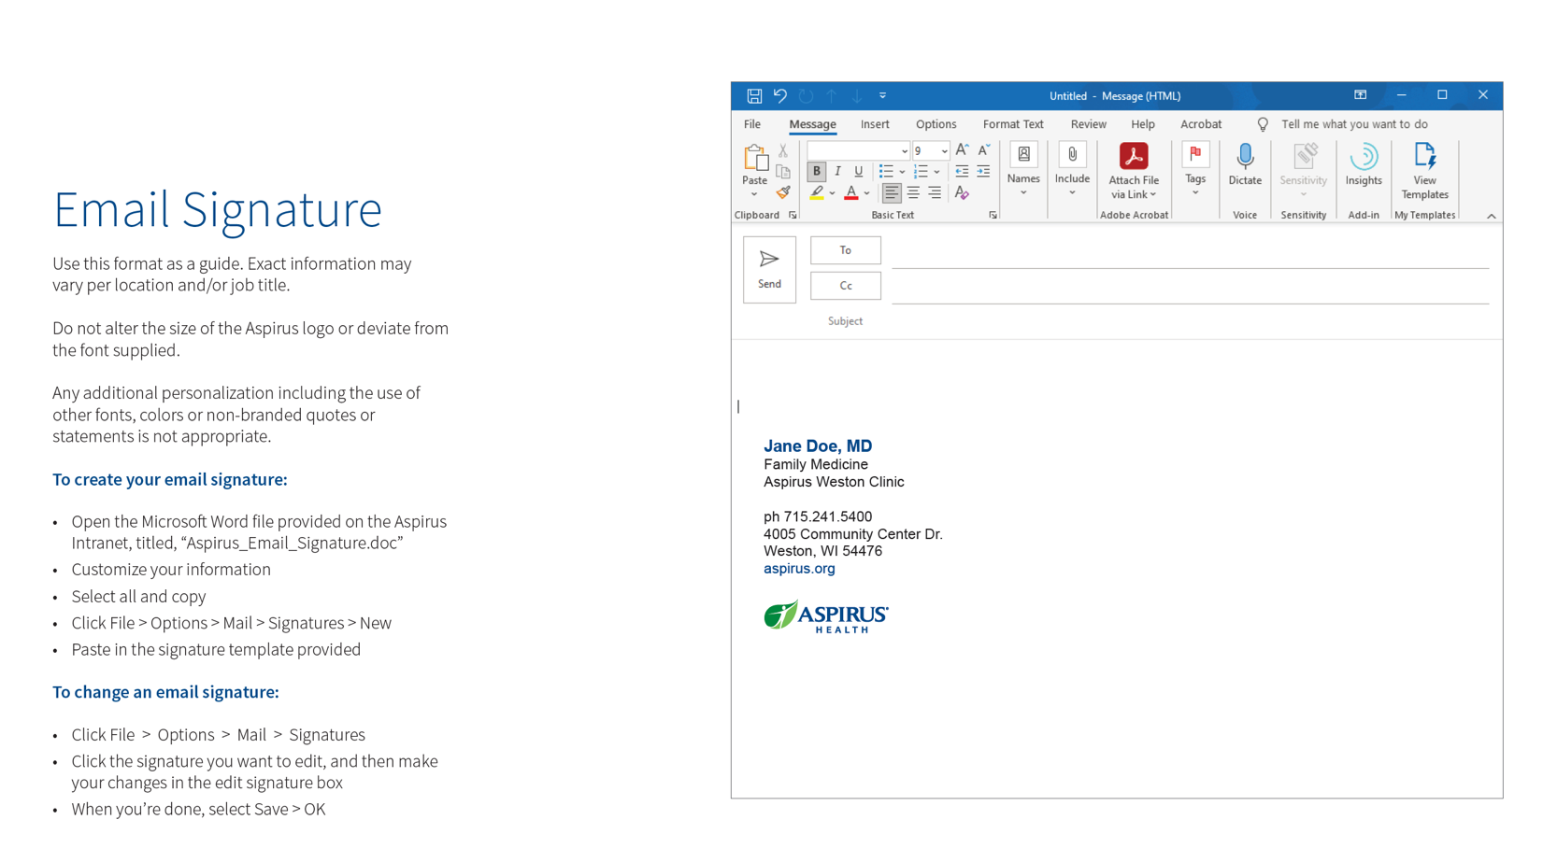

Email Signature
Use this format as a guide. Exact information may vary per location and/or job title.

Do not alter the size of the Aspirus logo or deviate from the font supplied.

Any additional personalization including the use of other fonts, colors or non-branded quotes or statements is not appropriate.

  - To create your email signature:
- Customize your information
- Select all and copy

To change an email signature:
- Login Via Citrix to your Outlook Email
- Click the settings gear in the upper right corner
- Click File > Options > Mail > Email Signature
- Paste in the signature template provided
- Click Save

Jane Doe, MD
Family Medicine
Aspirus Weston Clinic

ph 715.241.5400

4005 Community Center Dr.
Weston, WI 54476
aspirus.org



